Cell Theory Tree Map (pg 17)
DATE

Content Purpose:
Identify and demonstrate an understanding of the cell theory using a tree map.
Language Purpose:
Use scientific vocabulary when describing the parts of the cell theory (ex. cell, organism, living, etc.)
Use the following information to fill in the Cell Theory Tree Map. It must be in order of discovery.
The Cell Theory:
1. Cells are the basic unit of life
2. All living things are made of cells
3. Cells come from other cells
Virchow – Cells come from other cells
Hooke – cell (cork plant)
Schwann – animal (animals are made of cells as well)
Schleiden –plant (all plants are composed of cells)

Cell Theory Output (pg18)
DATE
Hook saw that the cork plant was made of tiny compartments he called cells – like cells in a Prison. 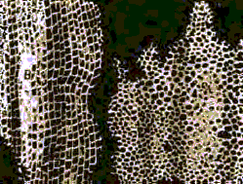
Schleiden saw that all the plants he looked at through his microscope were made of these things Hook called cells
Schwann saw that animals were also made of cells though they looked a bit different.
Virchow found cells splitting or dividing.
Summary (WILT)
In complete sentences answer the following questions about cell theory.
Who discovered cells?

How would you summarize cell theory?

What facts would you select to support cell theory?

